PROFESSIONAL ASSOCIATION OF MARTIAL ARTS
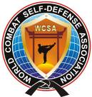

FIGHTS ORDER
WORLD CHAMPIONSHIP OF MARTIAL ARTS,
Yalta city, Ukraine. Date 09 october 2011

weight category | № circle | № fight | RED ANGLE RING |  | BLUE ANGLE RING
weight category | № circle | № fight | Surname/name | Country, club | Surname/name | Country, club
MMA-FULL /FREE-COMBAT
-57 | final | 1 | Marat Madiev | Russia | Orfan Sananzade | Ukraine
 |  |  |  | MADI | Orfan Sananzade | Bars
-60 | final | 2 | Hajibekov Haybula | Russia | Dancu Andrei | Romania
 |  |  |  | MADI | Dancu Andrei | Kempo Fed.
-63,5 | final | 3 | Kamil Magomedov | Russia | Constantin Gica | Romania
 |  |  |  | MADI | Constantin Gica | Kempo Fed.
-67 | final | 4 | Nanosetti Gabriele | Italy | Liviu Ionescu | Romania
 |  |  |  |  | Liviu Ionescu | Kempo Fed.
-71 | final | 5 | Shamhalaev Shakhbulat | Russia | Magomed Magomedov | Russia
 |  |  |  | Gorec | Magomed Magomedov | MADI
-75 | final | 6 | Pirtea Aurel | Romania | Machiev Abdurahman | Russia
 |  |  |  | Kempo Fed. | Machiev Abdurahman | Amanat
-81 | final | 7 | Imanali Imavov | Russia | Ibragimov Sultan | Russia
 |  |  |  | MADI | Ibragimov Sultan | MADI
-86 | final | 8 | Patrascu Mircea | Romania | Florea Sorin | Romania
 |  |  |  | Kempo Fed. | Florea Sorin | Kempo Fed.
-91 | final | 9 | Alibulatov Arthur | Ukraine | Nanonni Davide | Italy
 |  |  |  | Mangust | Nanonni Davide
+91 | final | 10 | Nepochatov Volodimir | Ukraine | Anatolie Ciumac | Romania
 |  |  |  | Champion | Anatolie Ciumac | Kempo Fed.

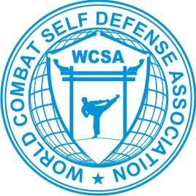
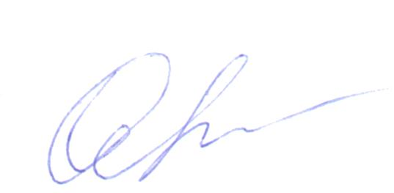

Secretary _______________ (Zinko Olena)

PROFESSIONAL ASSOCIATION OF MARTIAL ARTS
FIGHTS ORDER
WORLD CHAMPIONSHIP OF MARTIAL ARTS,
Yalta city, Ukraine. Date 09 october 2011

weight category | № circle | № fight | RED ANGLE RING |  | BLUE ANGLE RING
weight category | № circle | № fight | Surname/name | Country, club | Surname/name | Country, club
MMA-LIGHT/LIGHT-COMBAT
-56 | final | 1 | Marat Madiev | Russia | Zaharchenko Artem | Ukraine
 |  |  |  | MADI | Zaharchenko Artem | Zolotoy Yaguar
-60 | final | 2 | Kazihanov Musa | Russia | Omarov Mansur | Russia
 |  |  |  | MADI | Omarov Mansur | Combat S.D.
-65 | final | 3 | Kamil Magomedov | Russia | Constantin Gica | Romania
 |  |  |  | MADI | Constantin Gica | Kempo Fed.
-71 | final | 4 | Magomed Magomedov | Russia | Imanaliev Magomed | Russia
 |  |  |  | MADI | Imanaliev Magomed | MADI
-78 | final | 5 | Dragan Mirel | Romania | Bayramov Tural | Azerbaijan
 |  |  |  | Kempo Fed. | Bayramov Tural | Nefchi
-86 | final | 6 | Florea Sorin | Romania | Murad Ahmedov | Russia
 |  |  |  | Kempo Fed. | Murad Ahmedov | Amanat
+95 | final | 7 | Stoica Albert | Romania | Ciumac Anatolie | Romania
 |  |  |  | Kempo Fed. | Ciumac Anatolie | Kempo Fed.

Secretary _______________ (Zinko Olena)

PROFESSIONAL ASSOCIATION OF MARTIAL ARTS
FIGHTS ORDER
WORLD CHAMPIONSHIP OF MARTIAL ARTS,
Yalta city, Ukraine. Date 09 october 2011

weight category | № circle | № fight | RED ANGLE RING |  | BLUE ANGLE RING
weight category | № circle | № fight | Surname/name | Country, club | Surname/name | Country, club
ММА-ELITE/MIX-COMBAT
-60 | final | 1 | Lunga Alexander | Ukraine | Zeynulabidov Murad | Russia
 |  |  |  | HOOVFF | Zeynulabidov Murad | Combat S.D.
-65 | final | 2 | Curbanov Islam | Russia | Kelbaliev Zubair | Russia
 |  |  |  | Combat S.D. | Kelbaliev Zubair | Combat S.D.
-71 | final | 3 | Shamhalaev Shakhbulat | Russia | Sulebanov Ramazan | Russia
 |  |  |  | Gorec | Sulebanov Ramazan | Combat S.D.
-78 | final | 4 | Pirtea Aurel | Romania | Magomedov Rashid | Russia
 |  |  |  | Kempo Fed. | Magomedov Rashid | Gorec
-86 | final | 5 | Oedoev Ahmadhan | Russia | Cickiev Muslim | Russia
 |  |  |  | Koloy-team | Cickiev Muslim | Koloy-team
-95 | final | 6 | Alibulatov Arthur | Ukraine | Gamzatov Omar | Russia
 |  |  |  | Mangust | Gamzatov Omar | Combat S.D.
+95 | final | 7 | Gaivanovich Ivan | Ukraine | Kuniev Rizvan | Russia
 |  |  |  | Hanuman | Kuniev Rizvan | Combat S.D.

Secretary _______________ (Zinko Olena)

